



**35_Classes More Than 5 Students**

Write a pyspark code to find all the classes that have at least five students.Return the result table in any order.

**Difficult Level :** EASY

**DataFrame:**

**# Define the schema for the DataFrame**

**schema = StructType([**

**StructField("StudentID", StringType(), True),**

**StructField("ClassName", StringType(), True)**

**])**

**# Data to be inserted into the DataFrame**

**data = [**

**('A', 'Math'),**

**('B', 'English'),**

**('C', 'Math'),**

**('D', 'Biology'),**

**('E', 'Math'),**

**('F', 'Computer'),**

**('G', 'Math'),**

**('H', 'Math'),**

**('I', 'Math')**

**]**

|  |
| --- |
|  |



**INPUT**

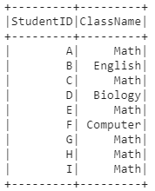

**OUTPUT**



